Pareto Chart
Pareto Charts (Figure 1) are created by collecting data and plotting them in a bar chart with descending order from left to right. It is then identified where approx. 80 percent of the effects is coming from (usually from approx. 20 percent of the potential causes). It is a great tool to focus on the most important items at hand.
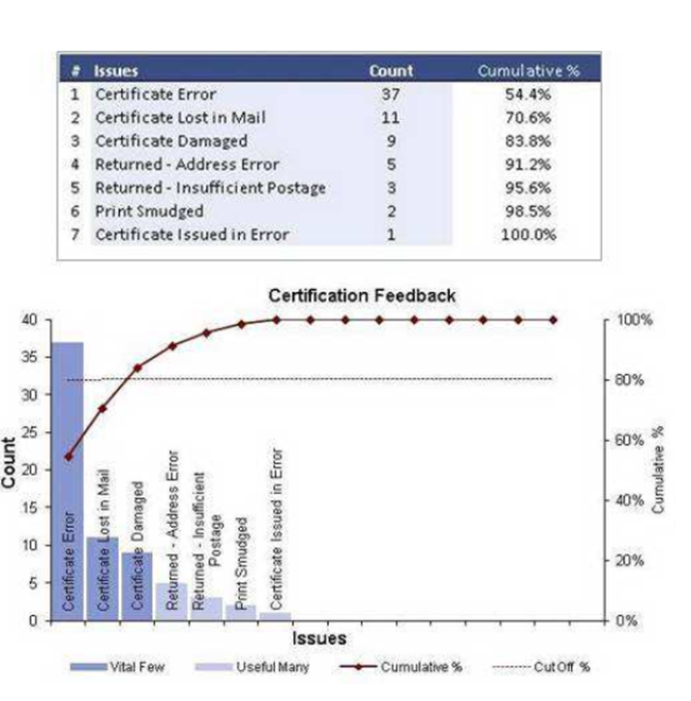
Figure 1: | Pareto Chart example

Ichikawa / Fishbone -Cause and Effect Assessment

Instructions (Figure 2)
- Enter the Problem Statement in the respective box to the right
- Brainstorm all major categories of the problem
- Add the categories as branches of the main categories in orange

Interpretation
Identify all possible causes, then select the most likely ones for further investigation. Additional tools such as Pareto, histograms, control charts or scatter plots may be used to assess the specific situation.

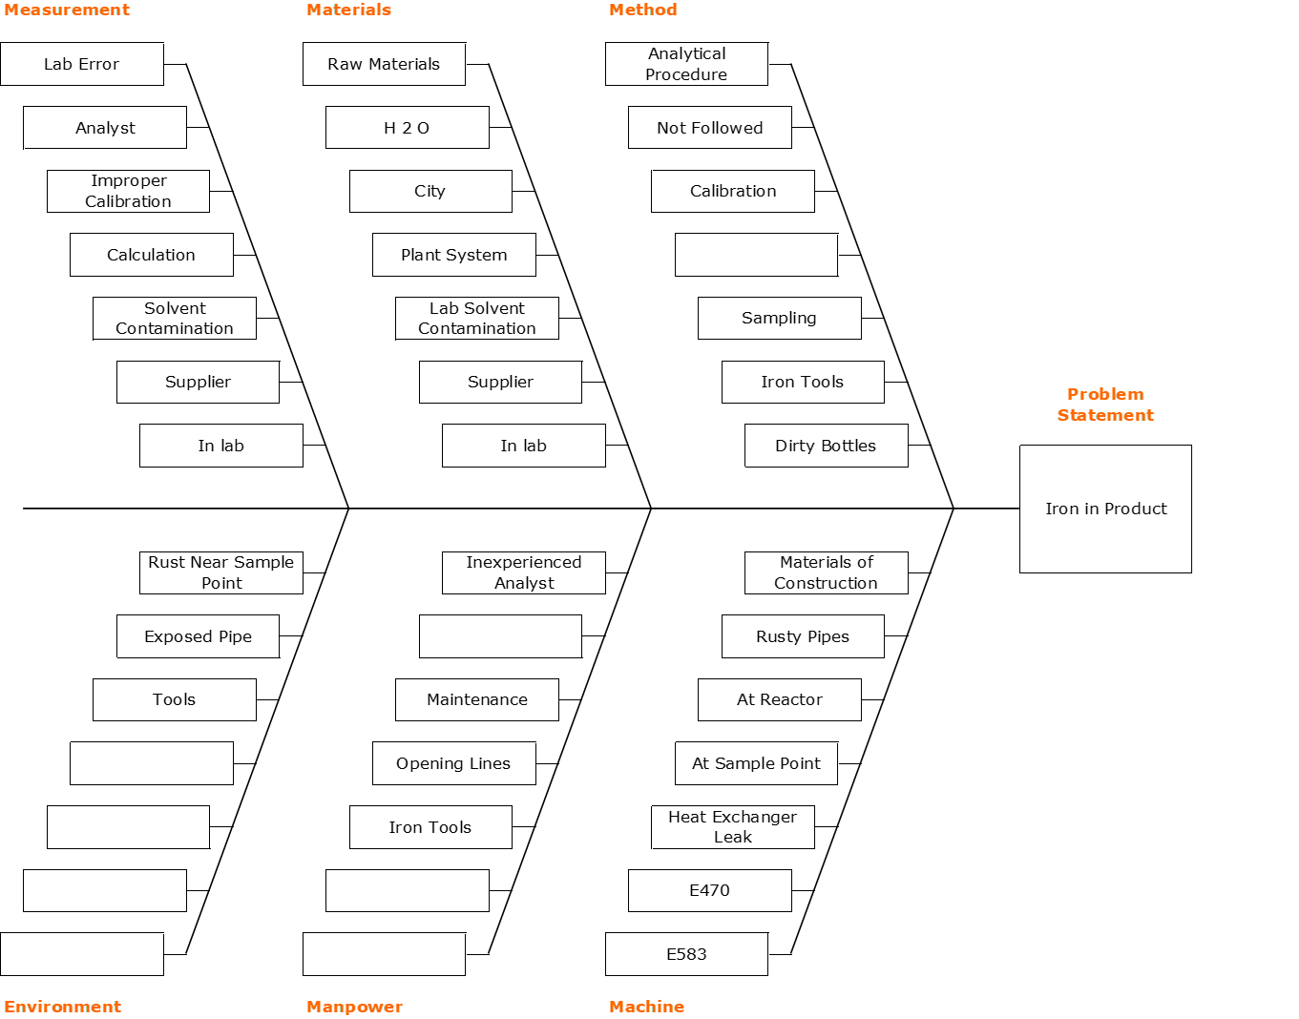
Figure 2: | Ichikawa / Fishbone example

Control Charts

Instructions
- Select the correct subgroup size, when in doubt use one.
- Identify any out-of-control conditions. Four tests are performed, with identifiable points in the legend.
Important notice: Control limits are not specification limits.

Interpretation
Control charts show important Trends and allow monitoring for process output over time to ensure robust processes.
Common causes of variation are inherent to every process and repeat randomly within predictable limits, such as:
- Chance causes
- Random causes
- System causes
- Inherent causes.
A process is only stable if it only shows common causes of variation.
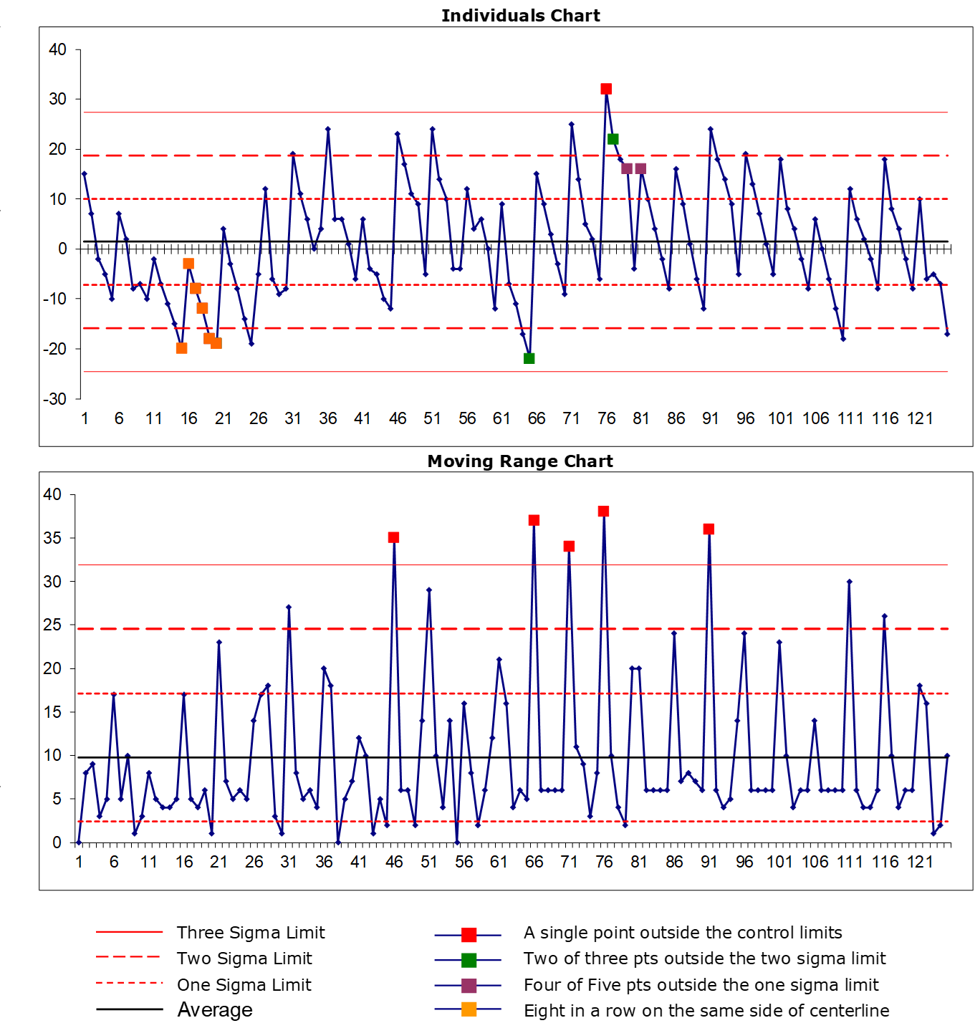
Figure 3: | Control Charts example

Histogram

Instructions (Figure 4)
Interpret a dataset via suitable software like JMP, MiniTab, or alike, to identify the distribution and variation of your data.
There are eight basic types of shapes that will be mentioned but not discussed in detail:
- Bell-shaped (normal, like the example below)
- Double-peaked (bimodal)
- Plateaued (multimodal)
- Combed
- Skewed
- Truncated (heart-shaped)
- Isolated peak
- Edge-peaked

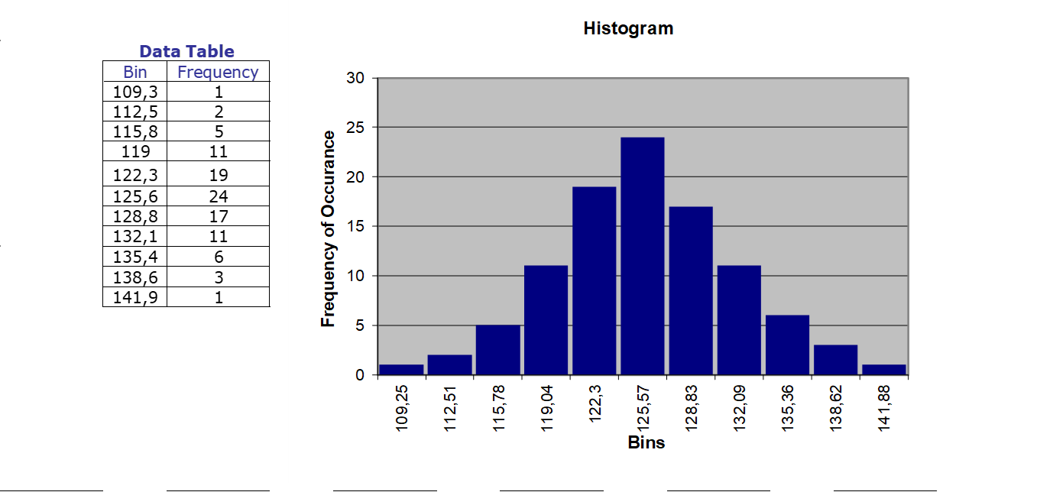
Figure 4: | Histogram example

Root Cause Analysis (RCA)

Five Why´s (Figure 5)
Is a technique to drill down through layers of causes and effects to the Root Cause. You keep asking until you reach the point when no further question makes reasonable sense. The number five is arbitrary and may be extended until a satisfying Root Cause is uncovered.
The determination of the true Root Cause is at the heart of any Corrective Action.
Make sure that during the RCA symptoms and root causes are not confused. Apparent causes may not be the true Root Cause. Try to keep the documentation of the RCA brief and simple.

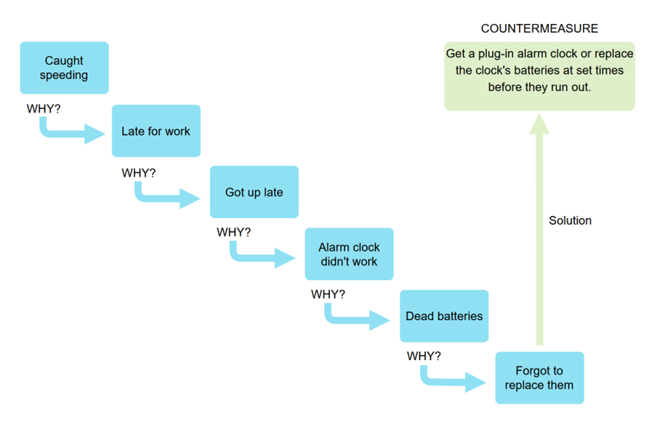
Figure 5: | Five Why´s example

PDCA (Plan-Do-Check-Act) or Deming Cycle
Layout a for-stage-reiterative approach to improving processes at all levels and stages of an organization (Figure 6).
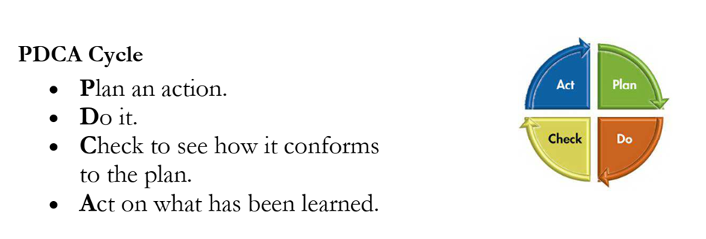
Figure 6: | PDCA (Plan-Do-Check-Act) or Deming Cycle

