Document approval
 | Name | Date | Signature
Author’s designation
e.g., Quality Specialist
Reviewer’s designation
e.g., Quality Management Director Deputy
Approver’s designation
e.g., Quality Management Director

Effective Date

Table of Contents

1 Purpose 2
2 Scope 2
3 Responsibilities 2
4 Definitions, terms and abbreviations 2
5 Workflow 3
6 Applicable documents 3
7 Appendices 3
8 Document revision history 3

Purpose
The purpose of this Standard Operating Procedure (SOP) is to ensure the high quality and safety of final products by providing a systemic approach to Quality Risk Management and identify and control Risk throughout various stages of a product’s manufacturing lifecycle.

Scope
This SOP is valid at Company CDE for all Organization. The respective training shall be given in accordance with SOP-10 CDE Training Management.

Responsibilities
Responsible for the content of this SOP is e.g., Quality Management Director.
Role | Definition /Task
Project Manager/Leads | - Work with Departments Leads to determine when a Risk Assessment is necessary  - Ensure that this SOP is followed when carrying out a Risk Assessment  - Assemble the project team and ensure the project team consists of experts of the Departments involved, SMEs, and individuals who are knowledgeable about Risk Management process and tools  - Leading the Team and manage the Risk Management process including development, creation and documentation of the Risk Management plan
Department  Heads / Team Leads | - Control Risk for areas for which they have direct oversight / responsibility  - Determine when a Risk Assessment is necessary
Quality Organization | - Provide guidance to the project team Management tools and techniques  - Maintain and ensure compliance with procedure  - File and retain related Risk Management records

Definitions, terms and abbreviations
Term/abbreviation | Definition at Company CDE
Risk Priority Number (RPN) | A priority ranking for the actions to be implemented based on the severity, impact and detectability. Each category is ranked from 1 to 3 with 3 being severe/critical and one being uncritical. The final RPN is calculated by multiplying the three factors. All items with RPN lower than 8 are considered acceptable, while 8-27 require some form of mitigation.
CAPA | CAPA refers to Corrective and Preventive Action. It is a systematic approach that includes actions required to correct, prevent recurrence, and eliminate the cause of potentially non-conforming products and other quality problems.
Detection | The means of Detection of the Failure mode by maintainer, operator or built-in Detection system, including estimated dormancy period (if applicable).
Failure cause and/or mechanism | Defects in requirements, design, process, quality control, handling or part applications, which are the underlying cause or sequence of causes that initiate a process (mechanism) that leads to a Failure mode over a certain time. A Failure mode may have multiple causes.
Failure effect | Immediate consequences of a Failure on operation, function or functionality, or status of some item.
Failure mode | The specific manner or way by which a Failure occurs. It is the result of the Failure mechanism (cause of the Failure mode) and should clearly state the end state of the failure.
Failure | The loss of an intended function of a product, equipment, system, devices, or processes under predefined conditions.
Fault Tree Analysis (FTE) | FTE is an approach that assumes Failure of the functionality of a product or process. This tool evaluates system (or sub-system) Failures one at a time but can combine multiple causes of Failure by identifying causal chains.
FMEA | FMEA refers for Failure Mode Effects Analysis, The FMEA is a design tool used to systematically analyze postulated component Failures and identify the resultant effects on system operations. It is a systematic, proactive method for evaluating a process to identify where and how it might fail and to assess the relative impact of different Failures, in order to identify the parts of the process that are most in need of change.
Occurrence | How often an event can occur, frequency.
RBA | RBA refers to Risk / Benefit Analysis. RBA determines if the benefits of the new process/product or change to a process/product outweigh the overall Residual Risk.
Residual Risk | Residual Risk is the Risk that remains after all reasonable efforts to identify and eliminate some or all types of Risk have been made.
Risk | The combination of the probability of Occurrence of harm and the Severity of that harm.
Risk Acceptance | The decision to accept Risk, mostly an outcome of low-risk implications or preset mitigation strategies.
Risk Analysis | The estimation of the Risk associated with the identified hazards.
Risk Assessment | A systematic process of organizing information to support a Risk decision to be made within a Risk management process. It consists of the identification of hazards and the analysis and evaluation of Risks associated with exposure to those hazards
Risk Communication | The sharing of information about Risk and Risk Management between the decision maker and other Stakeholders.
Risk Control | Actions implementing Risk Management decisions.
Risk Evaluation | The comparison of the estimated Risk to given Risk criteria using a quantitative or qualitative scale to determine the significance of the Risk.
Risk Identification | The systematic use of information to identify potential sources of harm (hazards) referring to the Risk question or problem description.
Risk Management | The systematic application of quality management policies, procedures, and practices to the tasks of assessing, controlling, communicating and reviewing Risk.
Risk Reduction / Risk Mitigation | Actions taken to lessen the probability of Occurrence, the Severity of that harm or increase its detectability.
Risk Review | Review or monitoring of output/results of the Risk Management process considering (if appropriate) new knowledge and experience about the Risk.
Severity | The consequences of a Failure mode; Severity considers the worst potential consequence of a Failure, determined by the degree of injury, property damage, system damage and/or time lost to repair the Failure.
Stakeholder | Any individual, group or organization that can affect, be affected by, or perceive itself to be affected by a Risk. Decision makers might also be Stakeholders. For the purposes of this guideline, the primary Stakeholders are the patient, healthcare professional, regulatory authority, and industry.

Workflow

General
This Risk Assessment process can be applied but is not limited to evaluation and decision-making regarding the implementation of or changes to the following:
- Product design
- Raw materials
- Drug product
- Drug substances (API)
- Packaging / labeling
- Processes / Systems
- Manufacturing
- Quality Control
- Distribution
- Inspection
- Validation
- Method changes
- Technology transfers
- Other decision making where Risk is inherent
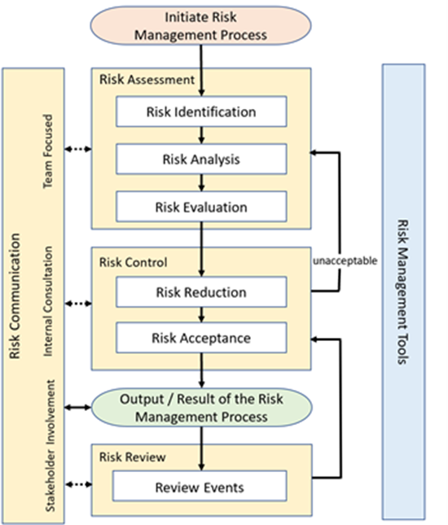
A Risk Management Process includes the following elements (Figure 1):
Figure 1: Risk Management Process

In preparation to perform the Risk Assessment address the following items upfront:
- Define the problem and/or risk question, including pertinent assumptions identifying the potential for risk;
- Assemble background information and/ or data on the potential hazard, harm or human health impact relevant to the Risk Assessment;
- Identify a leader and necessary resources;
Specify a timeline, deliverables and appropriate level of decision-making for the risk management process.

Risk Assessment

Risk Identification
Risk Identification may come from Quality Organization, Project Leads or Department Heads / Leads.
In order to properly identify Risk, it is important to collect any relevant data that may help identify Risk including new or revised standards, nonconforming material reports, supplier’s CAPAs, product complaints, customer inquiries, service reports, historical data, informed opinions, etc.
Step 1: Determine key differences in the changed/new state (proposed) from a point of reference or the original state.
- What might go wrong?
- How high is the probability / likelihood it will go wrong?

Step 2: Focus on the possible effects of the key differences from Step 1.
- What are the consequences?

Step 3: How likely can the failure be detected?

Detailed instructions on the execution and risk scoring are part of Failure Mode Effects Analysis (FMEA) Form.

Risk Analysis
Analyze the Risk associated with the problem by determining the likelihood and consequence of the identified Risks.
The ability to detect the harm should also factor into the estimation of Risk.
Several tools are available to perform Risk Analysis. Although not required, it is recommended to use a Failure Mode Effects Analysis (FMEA) for Risk Analysis (see Failure Mode Effects Analysis (FMEA) Form). Alternative methods are permissible as deemed suitable by the stakeholders. It is mandatory that alternative analysis also includes clear identification and evaluation of the risks, mitigation actions and strategies to control them, and a conclusion with an acceptance statement.

Risk Evaluation
During the Risk Evaluation identified Risk is compared against a given Risk criteria. Depending on the Risk Priority Number (RPN) mitigation actions will be implemented. A verification to assess the acceptability of the remaining risk will be noted. In the case other evaluation methods are used the same principles apply, only without any reliance on the RPN.

Risk Control

Risk Reduction
After identifying the risks and applying RPN, the members of the Risk Assessment team decide on actions to mitigate the Severity of the Risk, probability of harm or to improve detectability. Mitigation actions may include, but are not limited to:
- appropriate work instructions and SOPs
- train operators on the new procedure or equipment (ensure documentation)
- restrict access or exposure
- qualify equipment, operators and validate procedures (e.g., cleaning, production process)

All proposed mitigation measurements shall be managed according to SOP-07 CDE CAPA Management and reflected in associated Risk Assessment records for traceability.

Risk Acceptance
Risk Acceptance can be a formal decision to accept the Residual Risk post mitigation actions.

Risk Review
A Risk Review should be conducted to take into account new knowledge, experience, and events that may impact the original Risk Management decision. The frequency of any review should be based upon the level of Risk. Risk Review might include reconsideration of Risk Acceptance decisions.

Documentation and Communication
When completed, the Risk Management plan should include:
- background information and context (e.g., the Risk environment);
- the scope of the change or project proposed;
- the scope of the planned Risk Management activities;
- the strategy for managing the Risks. Describe the approach, responsibilities (and assignments), activities, timelines, and tools;
- methodology of any Risk calculation tools, including Risk Severity, probability, and acceptability;
- risk analyses and all Risk Evaluation tools utilized (e.g., FMEAs, Fault Tree Analysis);
- review of the Risk Management plan by the Head of the Department impacted, and other relevant Stakeholders, as necessary and approval by Head QM;
- records demonstrating the implementation and verification of the Risk Control measures and/or the acceptance of Risk.
Upon completion, the approved Risk Management plan is forwarded to QM for filing and retention.

Applicable documents
ICH Q9 Quality Risk Management
SOP-07 CDE CAPA Management
SOP-10 CDE Training Management

Appendices
The following appendix is integral part of this SOP:
Appendix Failure Mode Effects Analysis (FMEA) Form

Document revision history
Version | Valid from | Description of the revision | Reason for the revision
1 | See header | Document created | QMS implementation

